Tail dependence: USDJPY and USDCHF
Method 19 / daily log returns / alpha=0.05 / Alpari D1 full available history

Study setup
Logical pair: USDJPY , USDCHF
Broker symbols: USDJPY_i , USDCHF_i
Snapshot: 2026-11-03_majors_alpari_D1
Timeframe: D1
Matched return window: 1999-01-05 to 2026-11-02 (UTC bar dates)
Matched return count n: 7185
Dropped unfinished last bar dated 2026-11-03 UTC after a tick-volume check against the prior complete day.
Uniforms: ranks/(n+1); alpha=0.05
Complete matched rows (Excel): USDJPY-USDCHF_Tail_D1.xlsx
Complete matched rows (HTML table): USDJPY-USDCHF_Tail_D1_data.html

Method carried forward
Tail dependence counts how often both legs sit in an extreme uniform tail together. Matched daily log returns of close, ln(close_t / close_t-1), become u_i = rank(x_i)/(n+1) and v_i = rank(y_i)/(n+1). At alpha=0.05, lower L_hat = (# u<=alpha and v<=alpha) / (# conditioning leg <= alpha); upper uses >= 1-alpha. Both conditioning directions are reported with numerator and denominator counts. Quotes are not inverted. L_hat(0.05) is a finite-sample frequency, not the asymptotic lambda. Same-sample Pearson r is a side check. This is not causation and not a trading signal.

Results
tail | cond | L_hat | num | denom
lower | USDCHF | 0.267409 | 96 | 359
lower | USDJPY | 0.267409 | 96 | 359
upper | USDCHF | 0.228412 | 82 | 359
upper | USDJPY | 0.228412 | 82 | 359
Pearson r on returns: 0.399461

Conclusion
Over 7185 matched daily rows for USDJPY and USDCHF at alpha=0.05, lower L_hat conditioning on USDCHF is 0.2674 (96/359); conditioning on USDJPY is 0.2674. Upper L_hat conditioning on USDCHF is 0.2284; on USDJPY is 0.2284. Pearson r = 0.3995. These are finite-sample frequencies, not asymptotic lambda and not a trading signal.

Charts
Daily closes

Daily log returns

Uniforms with alpha lines
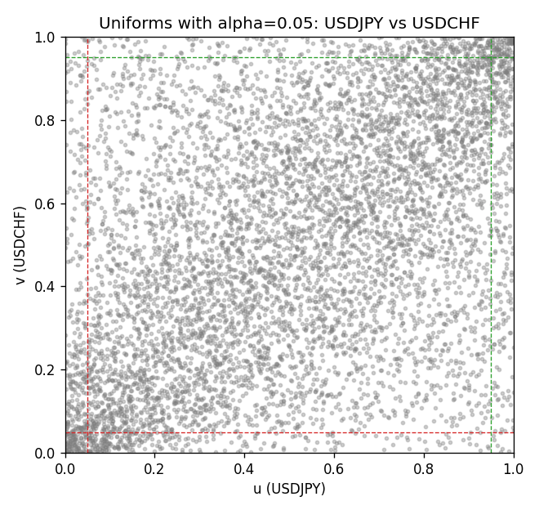

Data report
Every matched row is stored in the sibling Excel workbook named USDJPY-USDCHF_Tail_D1.xlsx, including u and v. Embedding all rows as a Word table is impractical; this file holds column summaries and the first and last 15 matched rows.
Columns: time, USDJPY_open, USDCHF_open, USDJPY_high, USDCHF_high, USDJPY_low, USDCHF_low, USDJPY_close, USDCHF_close, USDJPY_tick_volume, USDCHF_tick_volume, USDJPY_spread, USDCHF_spread, USDJPY_real_volume, USDCHF_real_volume, USDJPY_log_return, USDCHF_log_return, u, v
Column summaries (matched calculation rows)
column | count | mean | std | min | 25% | 50% | 75% | max
USDJPY_open | 7185 | 113.80726 | 19.2236 | 75.693 | 104.38 | 110.984 | 120.69 | 163.824
USDCHF_open | 7185 | 1.0974395 | 0.25223318 | 0.72022 | 0.92053 | 0.98988 | 1.2375 | 1.8219
USDJPY_high | 7185 | 114.30433 | 19.285132 | 76.001 | 104.865 | 111.442 | 121.257 | 163.978
USDCHF_high | 7185 | 1.1027315 | 0.25397793 | 0.73305 | 0.92474 | 0.99353 | 1.2422 | 1.8313
USDJPY_low | 7185 | 113.28455 | 19.151449 | 75.402 | 103.87 | 110.53 | 120.17 | 163.628
USDCHF_low | 7185 | 1.0923205 | 0.25064913 | 0.08565 | 0.91719 | 0.98622 | 1.2315 | 1.8121
USDJPY_close | 7185 | 113.82023 | 19.238853 | 75.811 | 104.38 | 111.025 | 120.68 | 163.851
USDCHF_close | 7185 | 1.0974333 | 0.25214008 | 0.72025 | 0.92079 | 0.98995 | 1.2376 | 1.8217
USDJPY_tick_volume | 7185 | 106345.59 | 179437.4 | 149 | 9958 | 53202 | 92889 | 1803508
USDCHF_tick_volume | 7185 | 74334.331 | 113494.7 | 18 | 12809 | 40241 | 70443 | 858589
USDJPY_spread | 7185 | 20.263883 | 17.612444 | 0 | 6 | 11 | 30 | 50
USDCHF_spread | 7185 | 26.03215 | 24.694045 | 0 | 5 | 16 | 50 | 100
USDJPY_real_volume | 7185 | 3.4781051e+10 | 1.6093614e+11 | 0 | 0 | 0 | 0 | 3.8834203e+12
USDCHF_real_volume | 7185 | 2.3294091e+10 | 8.9133595e+10 | 0 | 0 | 0 | 0 | 1.9331921e+12
USDJPY_log_return | 7185 | 4.82e-05 | 0.00620617 | -0.03908203 | -0.00320044 | 0.00011473 | 0.00340924 | 0.05184024
USDCHF_log_return | 7185 | -6.962e-05 | 0.0065941 | -0.19545699 | -0.0033516 | 8.06e-05 | 0.00332472 | 0.09051364
u | 7185 | 0.5 | 0.28865504 | 0.00013916 | 0.25006958 | 0.5 | 0.74993042 | 0.99986084
v | 7185 | 0.5 | 0.28865504 | 0.00013916 | 0.25006958 | 0.5 | 0.74993042 | 0.99986084
First 15 matched rows (selected columns)
time | USDJPY_log_return | USDCHF_log_return | u | v
1999-01-05 | -0.00017868311 | 0.0039424743 | 0.47119399 | 0.78360701
1999-01-06 | 0.0075660159 | 0.013605652 | 0.91163373 | 0.98371834
1999-01-07 | -0.012851583 | -0.0093883841 | 0.023239633 | 0.058725299
1999-01-08 | -0.0047719894 | 0.011040268 | 0.16852213 | 0.9670192
1999-01-11 | -0.016195423 | 0.0052963193 | 0.01335931 | 0.84497634
1999-01-12 | 0.032310364 | -0.0098275602 | 0.99958252 | 0.052602282
1999-01-13 | 0.0081373171 | -0.018259701 | 0.92499304 | 0.005844698
1999-01-14 | 0 | -0.0024256692 | 0.48740607 | 0.30489841
1999-01-15 | 0.0055343401 | 0.01794228 | 0.85179516 | 0.9948511
1999-01-18 | 8.7600193e-05 | -0.0031856384 | 0.49735597 | 0.25911495
1999-01-19 | -0.0056219403 | -7.2518946e-05 | 0.1394378 | 0.48622321
1999-01-20 | -0.0053879917 | 0.0072259871 | 0.14653493 | 0.90787643
1999-01-21 | 0.0084664056 | -0.0038232689 | 0.9295853 | 0.22669079
1999-01-22 | 0.0060412564 | -0.0001445609 | 0.86946841 | 0.47982188
1999-01-25 | -0.0073594164 | 0.0024546976 | 0.092262733 | 0.69120512
Last 15 matched rows (selected columns)
time | USDJPY_log_return | USDCHF_log_return | u | v
2026-10-13 | -0.0018932826 | -0.0024955621 | 0.32799889 | 0.30002783
2026-10-14 | 7.5800166e-05 | 0.0029388325 | 0.4955469 | 0.72502087
2026-10-15 | -0.0018524319 | -0.0097855323 | 0.33092124 | 0.053576399
2026-10-16 | -0.00037976126 | -0.0036230826 | 0.45004175 | 0.23810186
2026-10-19 | 0.0034946841 | 0.0036351779 | 0.75494016 | 0.76788199
2026-10-20 | -0.0022546642 | -0.0026281224 | 0.3039243 | 0.29195658
2026-10-21 | -0.00032883504 | -0.00040027413 | 0.45602561 | 0.45588645
2026-10-22 | -0.0085942669 | -0.0048036381 | 0.066796549 | 0.18369051
2026-10-23 | 0.00035080446 | 0.005652514 | 0.52184804 | 0.86028389
2026-10-26 | 0.0041238746 | 0.0018407959 | 0.7915391 | 0.64333426
2026-10-27 | 0.0027651658 | 0.0026100526 | 0.71166156 | 0.70094628
2026-10-28 | -0.00095679538 | -0.0010142111 | 0.39813526 | 0.40787643
2026-10-29 | -0.00038043789 | -0.0048680164 | 0.44990259 | 0.180629
2026-10-30 | -0.0010596481 | 0.00071594559 | 0.39159477 | 0.5535764
2026-11-02 | 0.0026438521 | -0.0071459744 | 0.70359031 | 0.10283885

